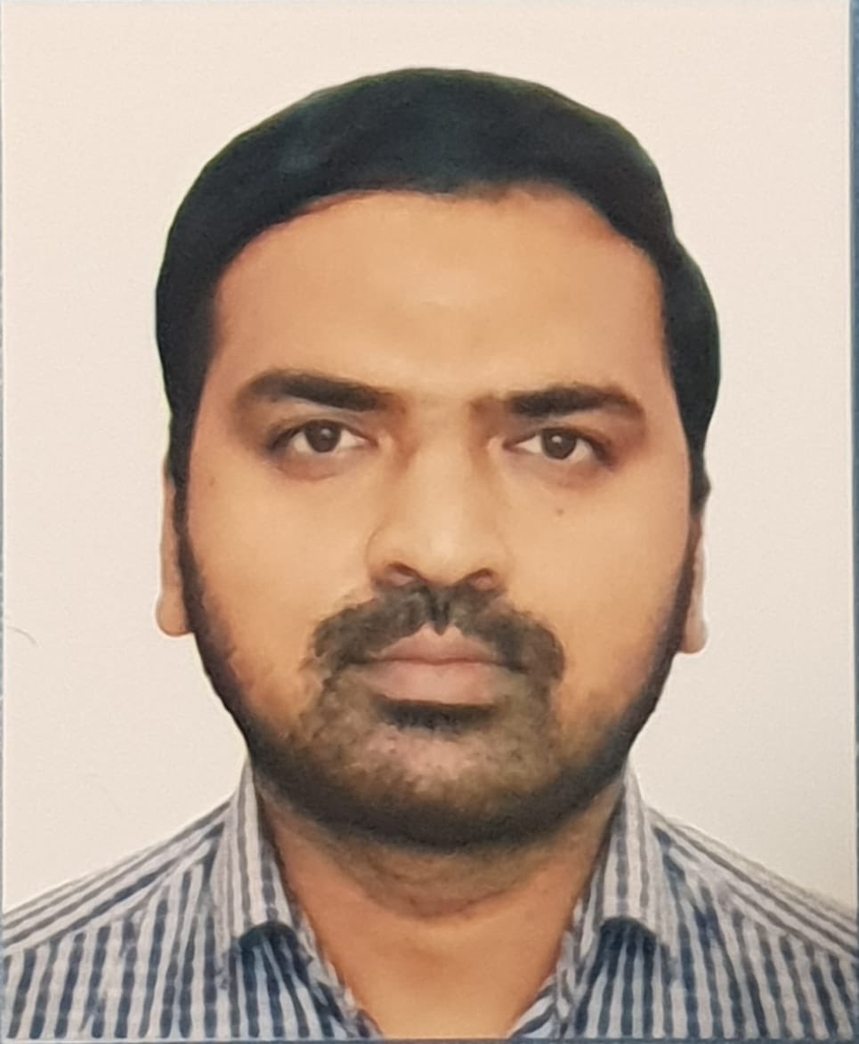

Confident & Motivated

Team Player

Vibrant Personality

Interpersonal  
Communication Skills

Quick Learner

Adaptable to change &   
challenges

Ph.D. in chemical engineering (Corrosion & Material Science)

University of Guadalajara, Jalisco, Mexico.

From 2018 to continue

Master in Petroleum Engineering (Production & Drilling),

University of Zulia, Maracaibo, Venezuela.

2013 – 2016

Bachelor of Mechanical Engineering,

Quest Nawabshah, Pakistan.

2005-2009

EDUCATION

English: Full Professional

Spanish: Full Professional

Urdu: Full Professional

Arabic: Basic

Gujarati: Native

EXPERIENCE

PROFESSIONAL PROFILE

ABDUL MALIK

|MECHANICAL ENGINEER|

(OPERATIONS, SALES, PRODUCTION)

**Ph.D. Researcher**

*American University of Sharjah, United Arab Emirates.*

December 2020 – to continue

* Research in material science and corrosion engineering.
* Handling corrosion testing machines their testing and maintenance.
* Preparing study plans for students.

**Sr. Sales Engineer**

*Filtors de Joe,**Jalisco,**Mexico*

November 2018 to October 2020

* Responsible for upgradation of sales team and implement a new culture of wining.
* Designed all sales compensation programs to drive sales of key products.
* Acquire and Identify potential clients, and the decision makers within the client organization for an increased business growth.
* Endeavour to build healthy bonds with new clients.

**Technical Sales Engineer**

*Safe Technical Supply Company – Karachi, Pakistan.*

November 2017 – July 2018

* Headed technical sales team in Pak region for all filtrations & Swagelok products, providing pre-sales technical assistance also providing after sales services in the companies like Oil & Gas, Petrochemicals, Power Generations & Shipbuildings.
* Promoting Boll & Kirch & Hilliard’s filtration products through customer approach and a professional approach to the job in hand fostering good relations opening opportunities for new and continued business.
* Updating clients on our OEM’s products and services, identify and also discuss with our existing and new clients any future work requirments which we could develop into additional buisness and pull through oppurtunities for other our company’s product lines

**Engineer at Operations department.**

*Nabors drilling International – Maracaibo, Venezuela.*

April 2015 – March 2016

* Supervising day to day operations and also did my master in petroleum engineering thesis with this company. Topic was “Proposal of a Bottom Hole Assembly (BHA) to minimize the impact of vibrations in the Wells of Boscan Field.

Ambitious and energetic mechanical engineer with a professional experience of over 7 years in different sectors including oil and gas, petrochemicals, and manufacturing industries. My key objective is to associate with an innovative and vibrant organization, which allows me to put my skills and competencies to the best use, add value to the organization and contribute to my overall growth as an individual. I deem in taking systematic, but dynamic approach towards new responsibilities and challenges and further my career.

LANGUAGES

+971553570780

SKILLS

Malikshk7861 @  
gmail.com

Dubai, UAE

https://www.linkedin.com/in/malikshk786/



* AutoCAD (2D & 3D)
* Pro-Engineering wild fire 2.0
* Programmable Logic Controller (PLC Mitsubishi)
* Microsoft Office, Windows Xp
* Personal Survival Techniques IMO 1.19
* Fire Prevention IMO 1.2
* Elementary First Aid IMO 1.3
* Personal Safety & Social Responsibility IMO 1.21
* Helicopter Under Water Escape Training (A.3)
* Well Logging
* Basic Reservoir Engineering
* Basic Drilling Engineering
* Basic Geology
* Introduction to Production Engineering

COURSES

COMPUTER  
SKILLS

|MECHANICAL ENGINEER|

(OPERATIONS, SALES, PRODUCTION)

ABDUL MALIK

+971553570780

**Plant Engineer**

*Roads Technology Company, AL Ahsa Saudi Arabia.*

Aug 2010 – June 2013

* Involved from the beginning, lay out, procuring Mixing Plant, Essentials equipment like pumps, motors & other mechanical and electrical equipment for whole erection and commissioning of the Italian Plant.
* Production & QC of polymer modified bitumen plant & Asphalt Emulsion plant. Troubleshooting & Mechanical Maintenance.

**Mechanical Design Engineer**

*Karachi shipyard and engineering works ltd. Karachi, Pakistan.*

Jan 2009 – July 2010

Serve

* Commissioning of main & auxiliary equipment of ship machinery like (Main Engine, Generators, Azimuth thruster & Bow thruster.
* Inspect the system drawings of engine room machinery, (Exhaust system, fuel oil system, Co2 Firefighting system, Sea water system, Fresh water system, Lubrication system, Bilges/Ballast system etc.
* Involvement in the project (02 X pusher tugs & 01 X Dredge tender for Karachi port trust.
* Organizing weekly production meeting.

**REFERENCE:**

* Available and would be provided upon request.

**REGISTRATION:**

* Pakistan Engineering Council Registration No: MECH / 22363 (LIFE TIME MEMBER).

**DECLERATION:**

* I hereby declare that the information given above is true to the best of my knowledge and I bear the responsibility for the correctness of the above-mentioned particulars.

Place: Dubai, UAE. ABDUL MALIK

EXPERIENCE continued

https://www.linkedin.com/in/malikshk786/

Dubai, UAE

Malikshk7861@  
gmail.com